**Prasanna Nimbalkar**

**NUID: 002111122**

PART 2 - PROGRAMMING ASSIGNMENT  
 Write a .bat/.sh to import the entire NYSE dataset (stocks A to Z) into MongoDB.  
 NYSE Dataset Link: <http://newton.neu.edu/nyse/nyse.zip>

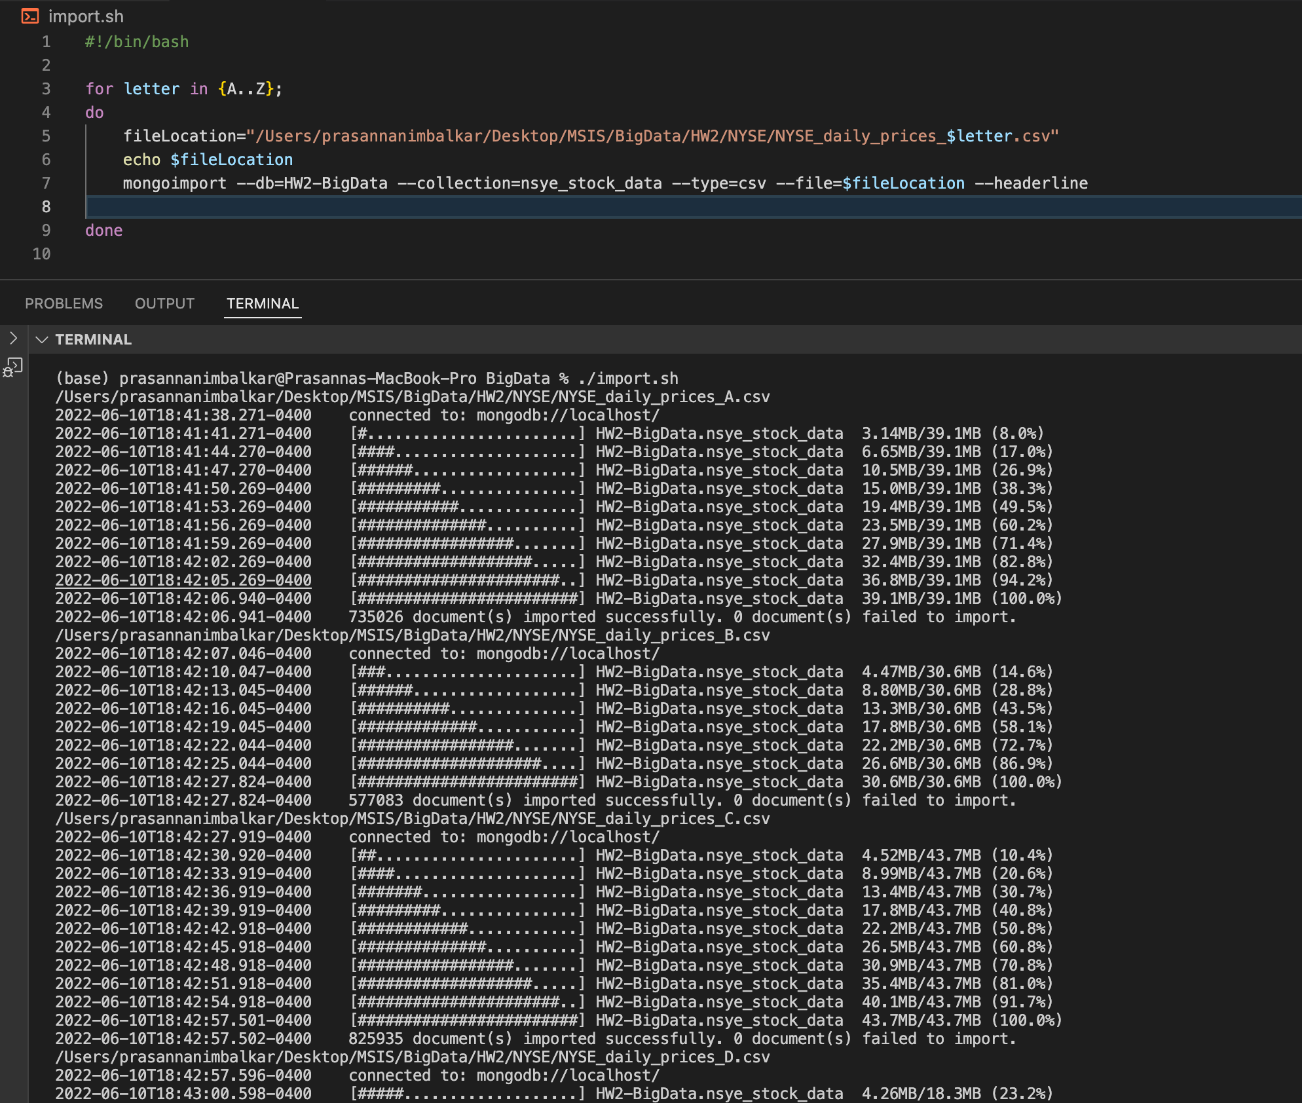

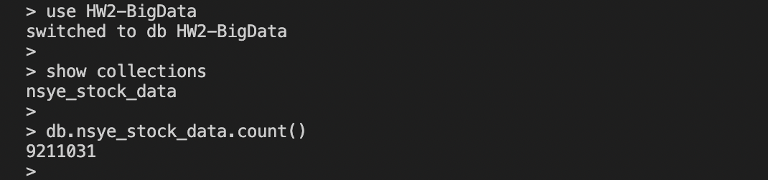

=====================================

PART 3.1. Use the NYSE database to find the average price of stock_price_high values for each stock using MapReduce.

var map_avg_stock_price_high = function () { emit(this.stock_symbol, this.stock_price_high) }

var reduce_avg_stock_price_high = function(stock_letter, stock_price_high_array) { return Array.avg(stock_price_high_array)}

db.nsye_stock_data.mapReduce( map_avg_stock_price_high, reduce_avg_stock_price_high, { out: "mapReduce_stock_price_high" })

{ "result" : "mapReduce_stock_price_high", "ok" : 1 }

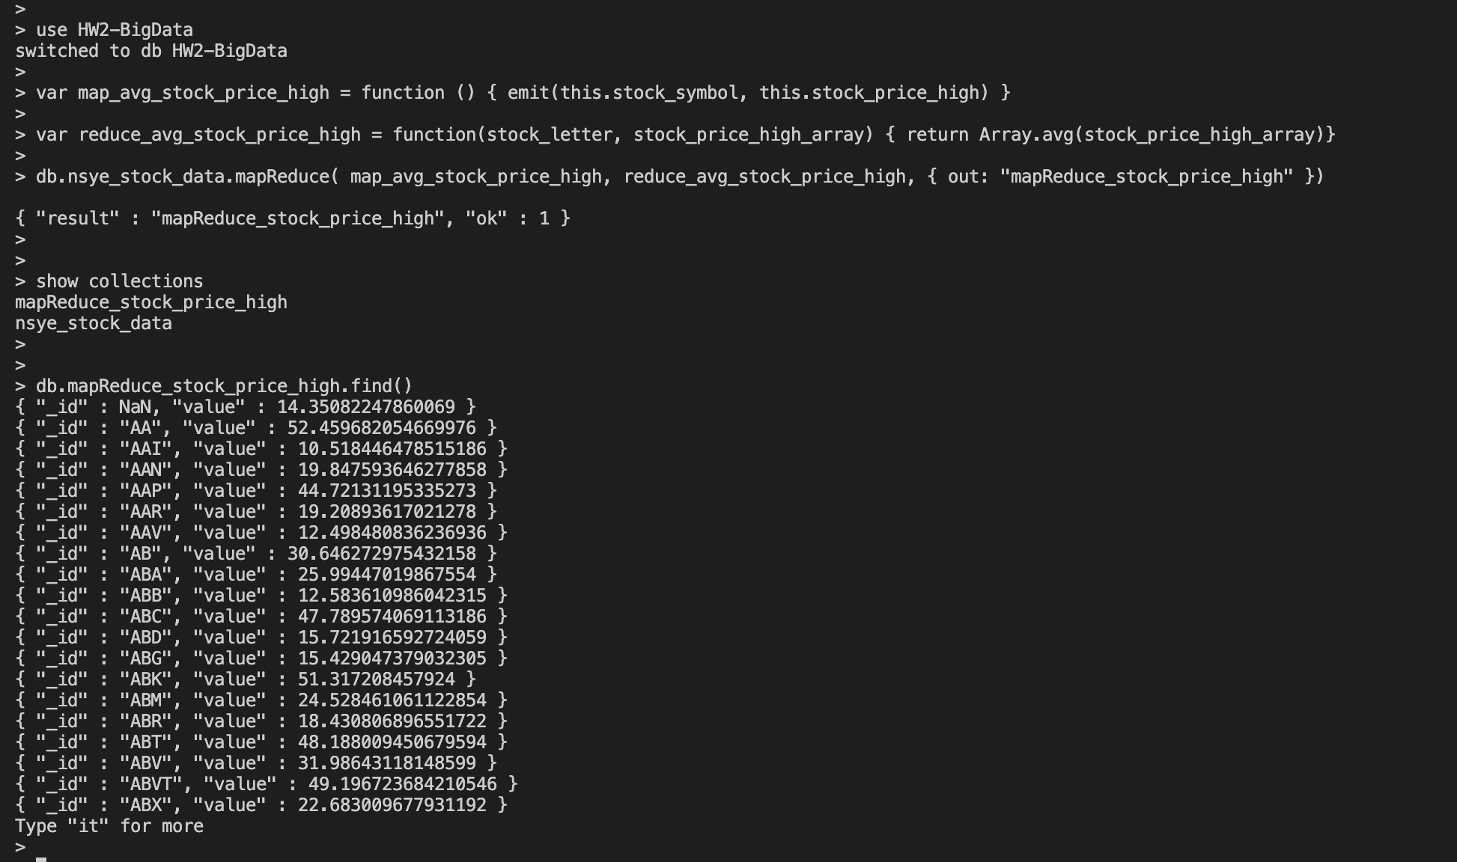

=====================================

PART 3.2. Part 3.1 result will not be correct as AVERAGE is a commutative operation but not associative. Use a FINALIZER to find the correct average.  
(Hint: pass sum and count from the reducer)  
(<https://docs.mongodb.com/manual/reference/method/db.collection.mapReduce/index.html>)

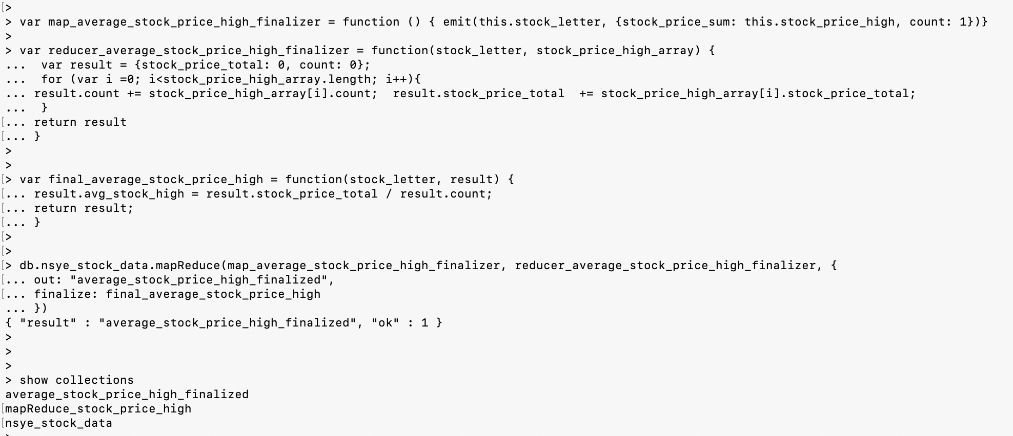

var map_average_stock_price_high_finalizer = function () { emit(this.stock_letter, {stock_price_sum: this.stock_price_high, count: 1})}

var reducer_average_stock_price_high_finalizer = function(stock_letter, stock_price_high_array) {

var result = {stock_price_total: 0, count: 0};

for (var i =0; i<stock_price_high_array.length; i++){

result.count += stock_price_high_array[i].count; result.stock_price_total += stock_price_high_array[i].stock_price_total;

}

return result

}

var final_average_stock_price_high = function(stock_letter, result) {

result.avg_stock_high = result.stock_price_total / result.count;

return result;

}

db.nsye_stock_data.mapReduce(map_average_stock_price_high_finalizer, reducer_average_stock_price_high_finalizer, {

out: "average_stock_price_high_finalized",

finalize: final_average_stock_price_high

})

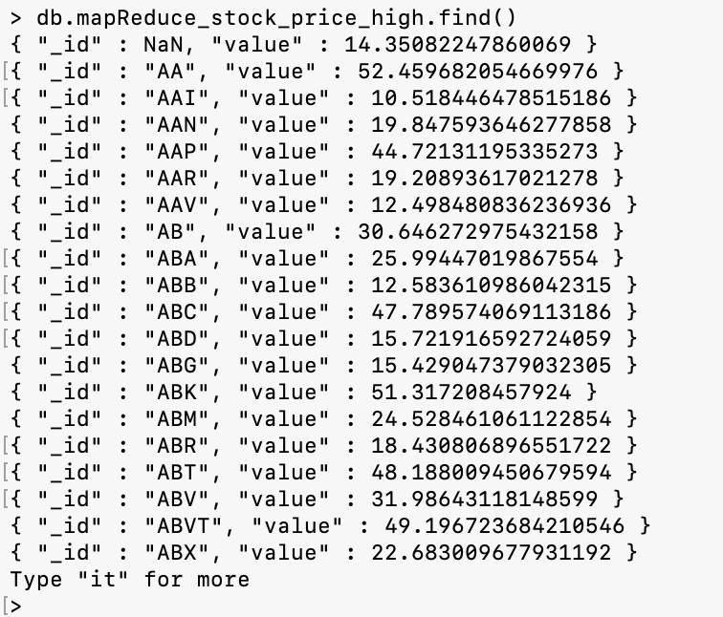

=====================================

PART 4. Calculate the average stock price of each price of all stocks using $avg aggregation.  
[https://docs.mongodb.com/manual/reference/operator/aggregation/avg/ (Links to an external site.) (Links to an external site.)](https://docs.mongodb.com/manual/reference/operator/aggregation/avg/)

db.nsye_stock_data.aggregate([

{ $group:

{ _id: "$stock_letter", averageStockPrice:

{ $avg: "$stock_price_high" }

}

} ])

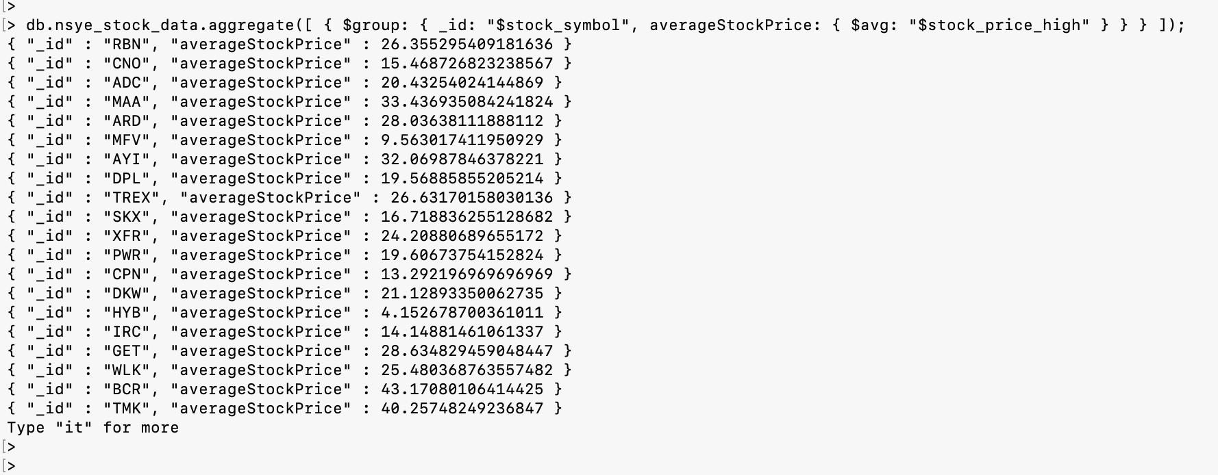

=====================================

PART 5.1 - PROGRAMMING ASSIGNMENT  
Import the Movielens dataset into MongoDB. Refer to README about file contents and headings.  
[https://grouplens.org/datasets/movielens/1m/ (Links to an external site.) (Links to an external site.)](https://grouplens.org/datasets/movielens/1m/)   [you may replace :: in the dateset with comma or tab to import]

1. Find the number Females and Males from the users collection using MapReduce. Do the same thing using count() to compare the results.

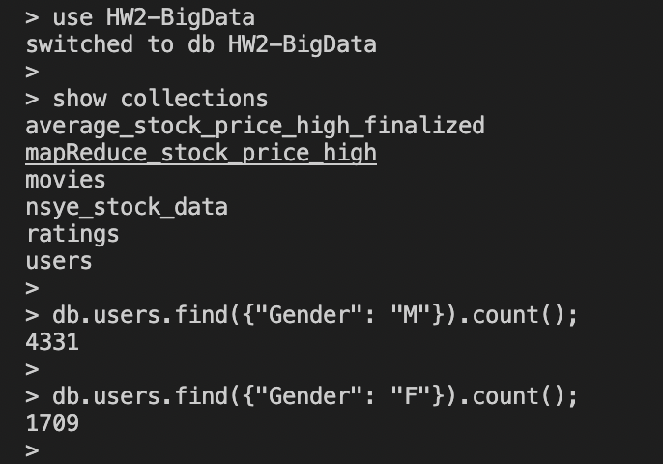

Using MapReduce count

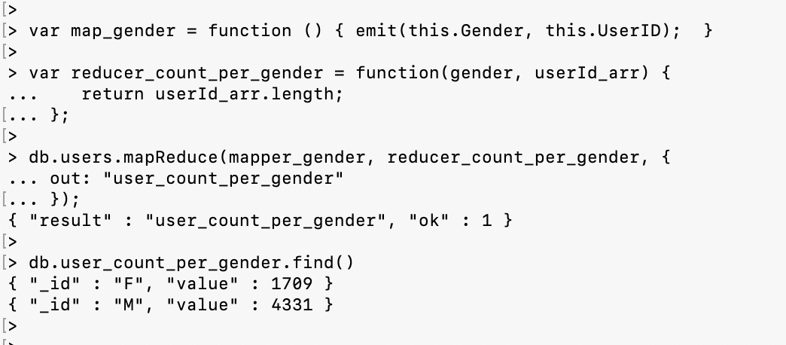

=====================================

1. Find the number of Movies per year using MapReduce

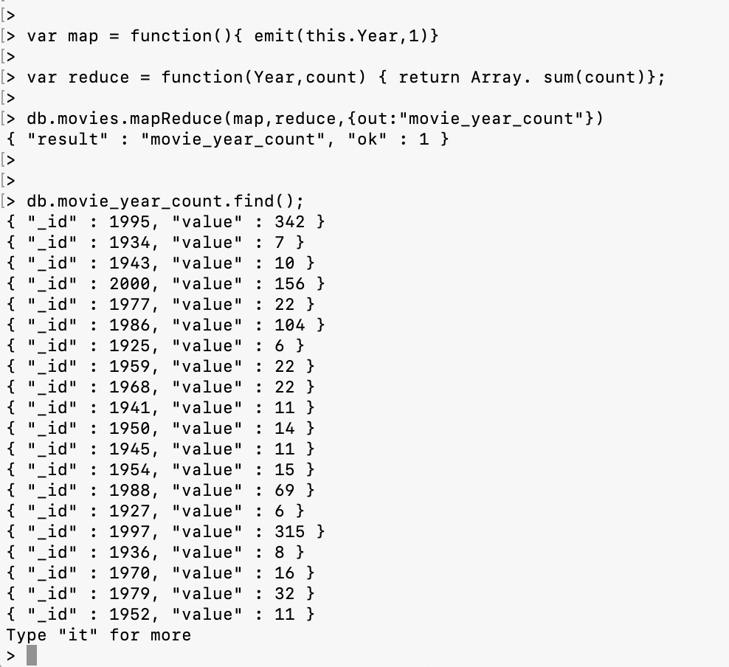

=====================================

1. Find the number of Movies per rating using MapReduce

var mapper_movies_per_rating = function () {

emit(this.Rating, this.MovieID);

};

var reducer_movies_per_rating = function(year, movieId_arr) {

return movieId_arr.length;

};

db.ratings.mapReduce(mapper_movies_per_rating, reducer_movies_per_rating, {

out: "movie_count_per_rating"

});

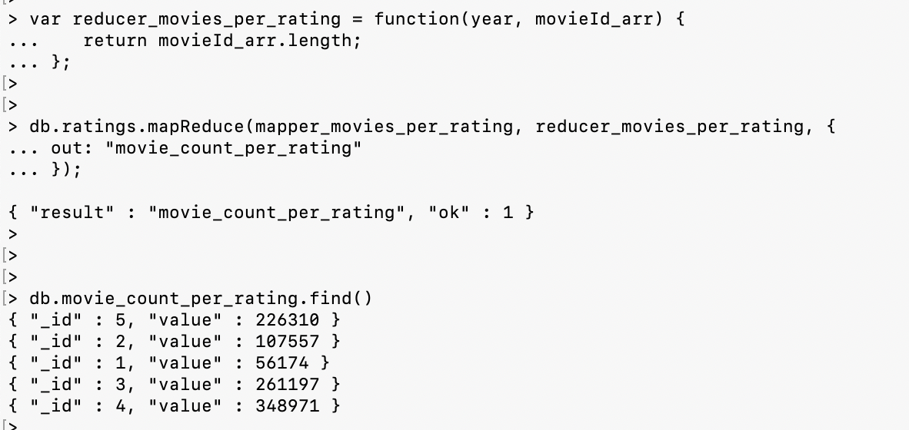

=====================================

PART 5.2 - PROGRAMMING ASSIGNMENT  
  Repeat 5.1 using Aggregation Pipeline.

1. Find the number Females and Males from the users collection using MapReduce.

db.users.aggregate([

{ $group: { _id: "$Gender", byGender: {$count: {}} } }

]);

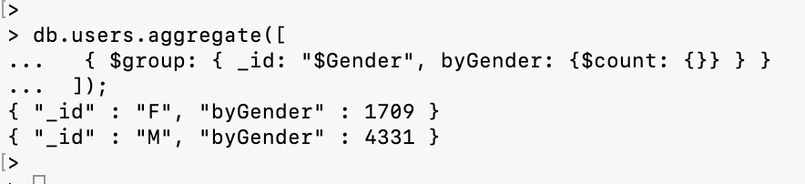

2. Find the number of Movies per year

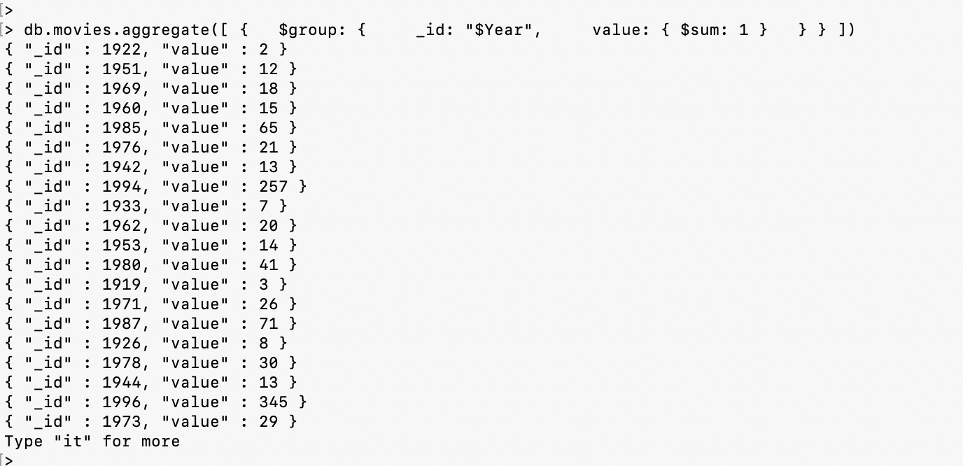

1. Find the number of Movies per rating using MapReduce

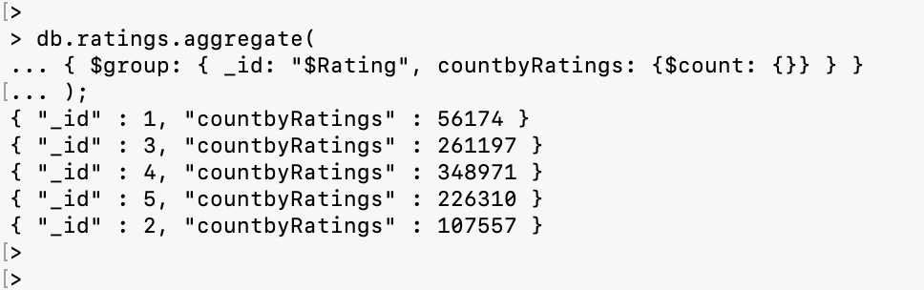

=====================================

PART 6 - PROGRAMMING ASSIGNMENT [[access.log](https://northeastern.instructure.com/courses/113703/files/15772123?wrap=1)[Download access.log](https://northeastern.instructure.com/courses/113703/files/15772123/download?download_frd=1)]  
Write a Java (could be a console app - will only run once to import the data into MongoDB) program to read the access.log file (attached), and insert into access collection.  Once the data are inserted into MongoDB, do the followings using

Importing access log

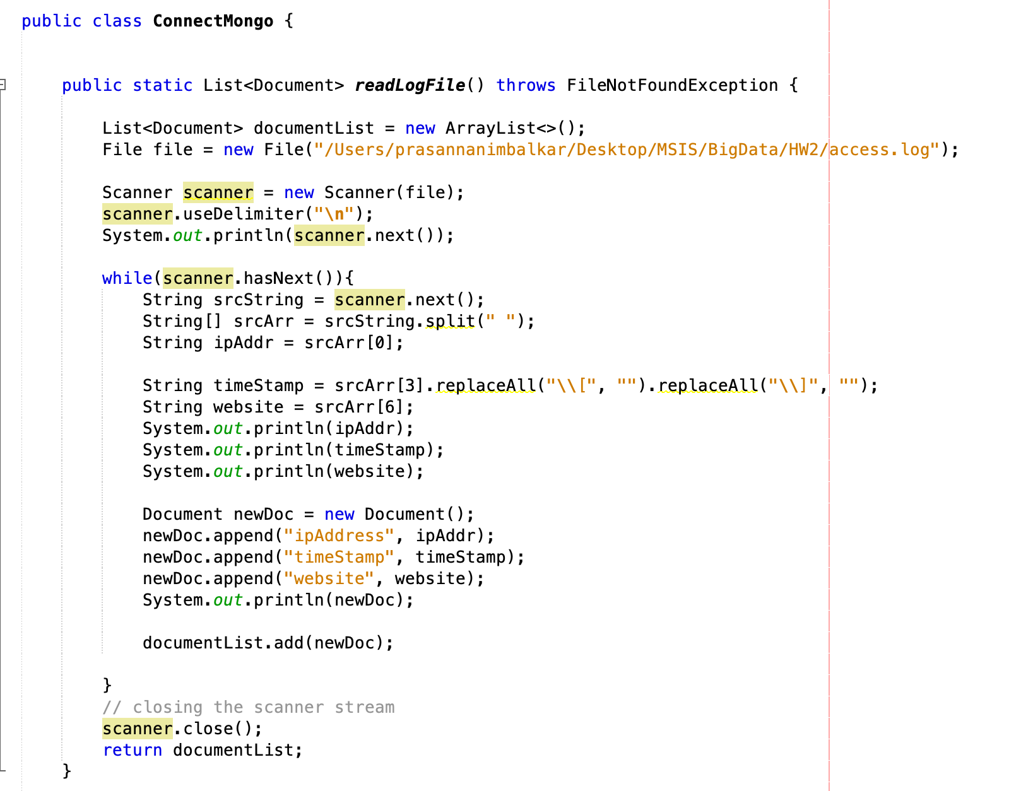

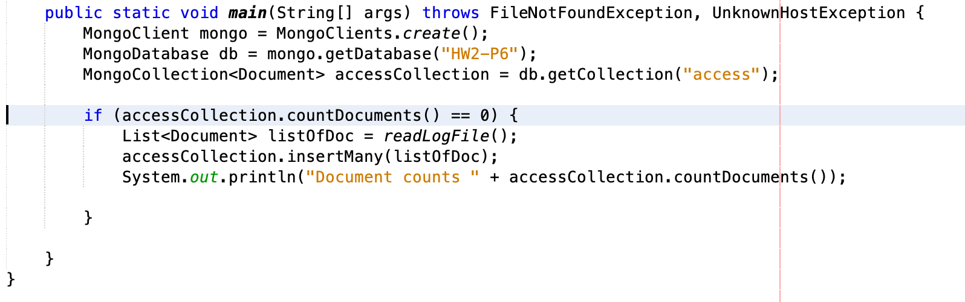

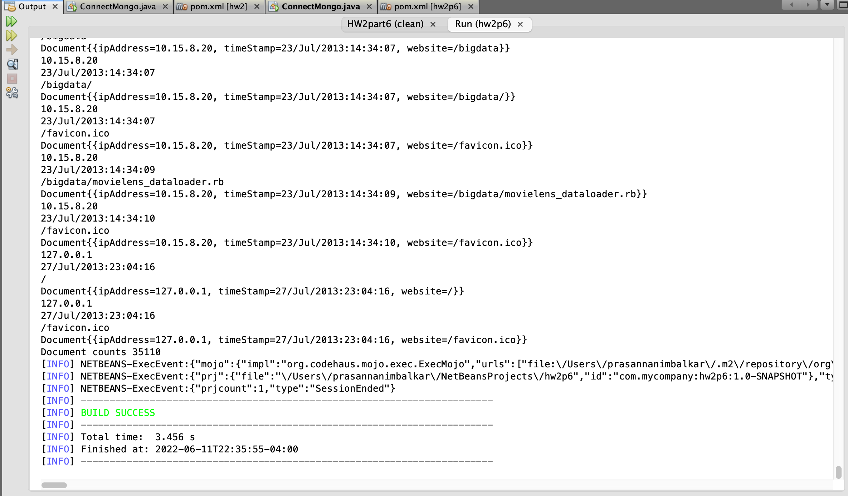

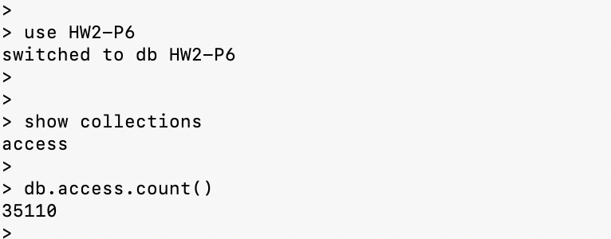

Part6-1 MapReduce:  
- Number of times any webpage was visited by the same IP address.

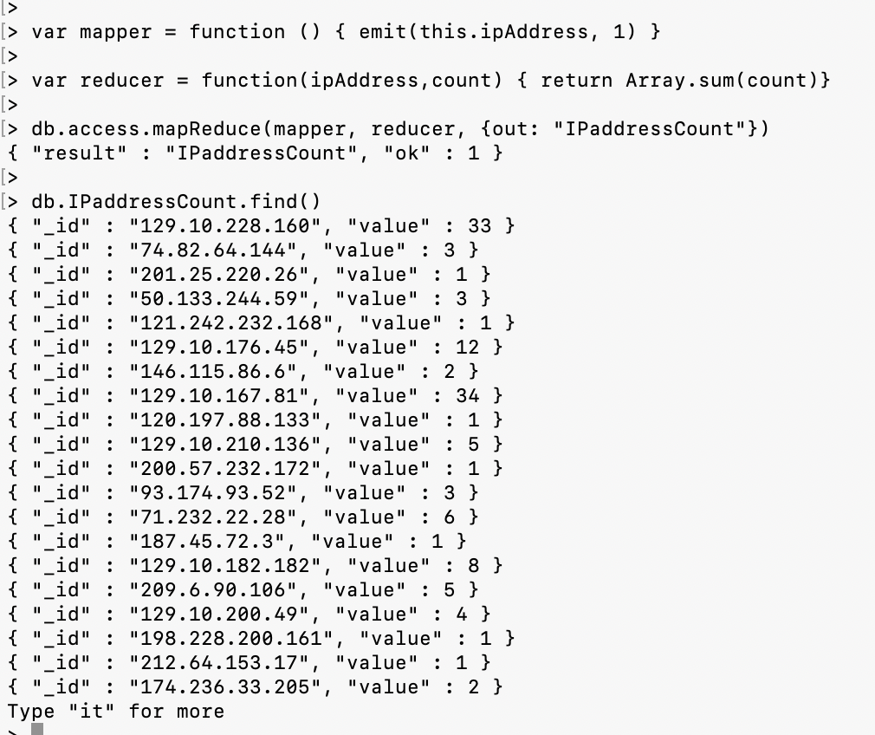

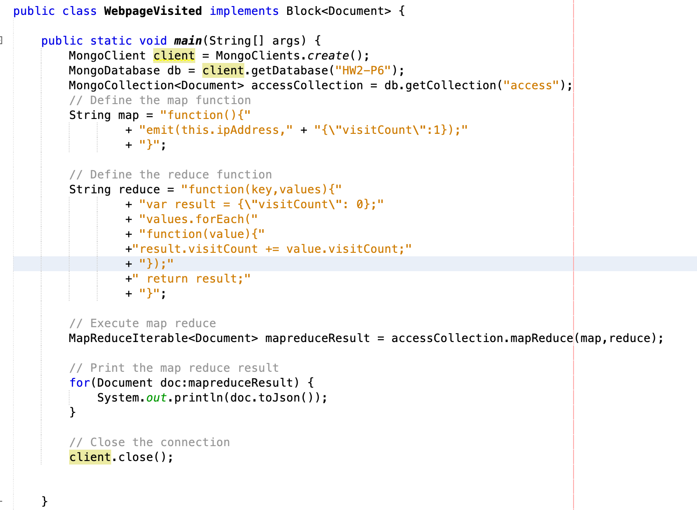

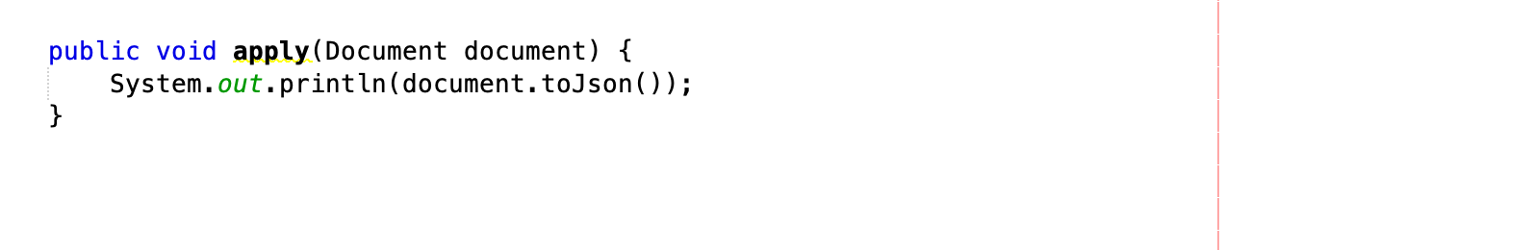

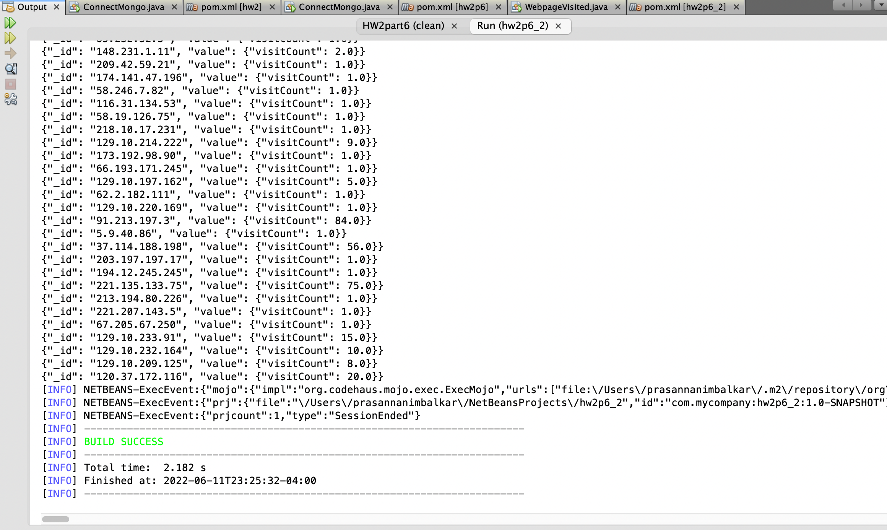

Part6-2

- Number of times any webpage was visited each month.

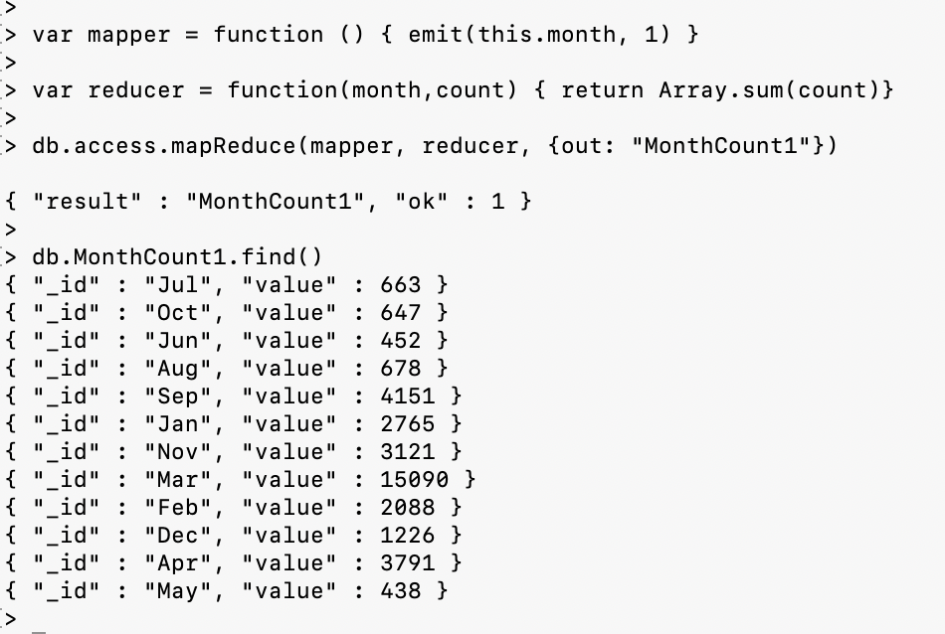

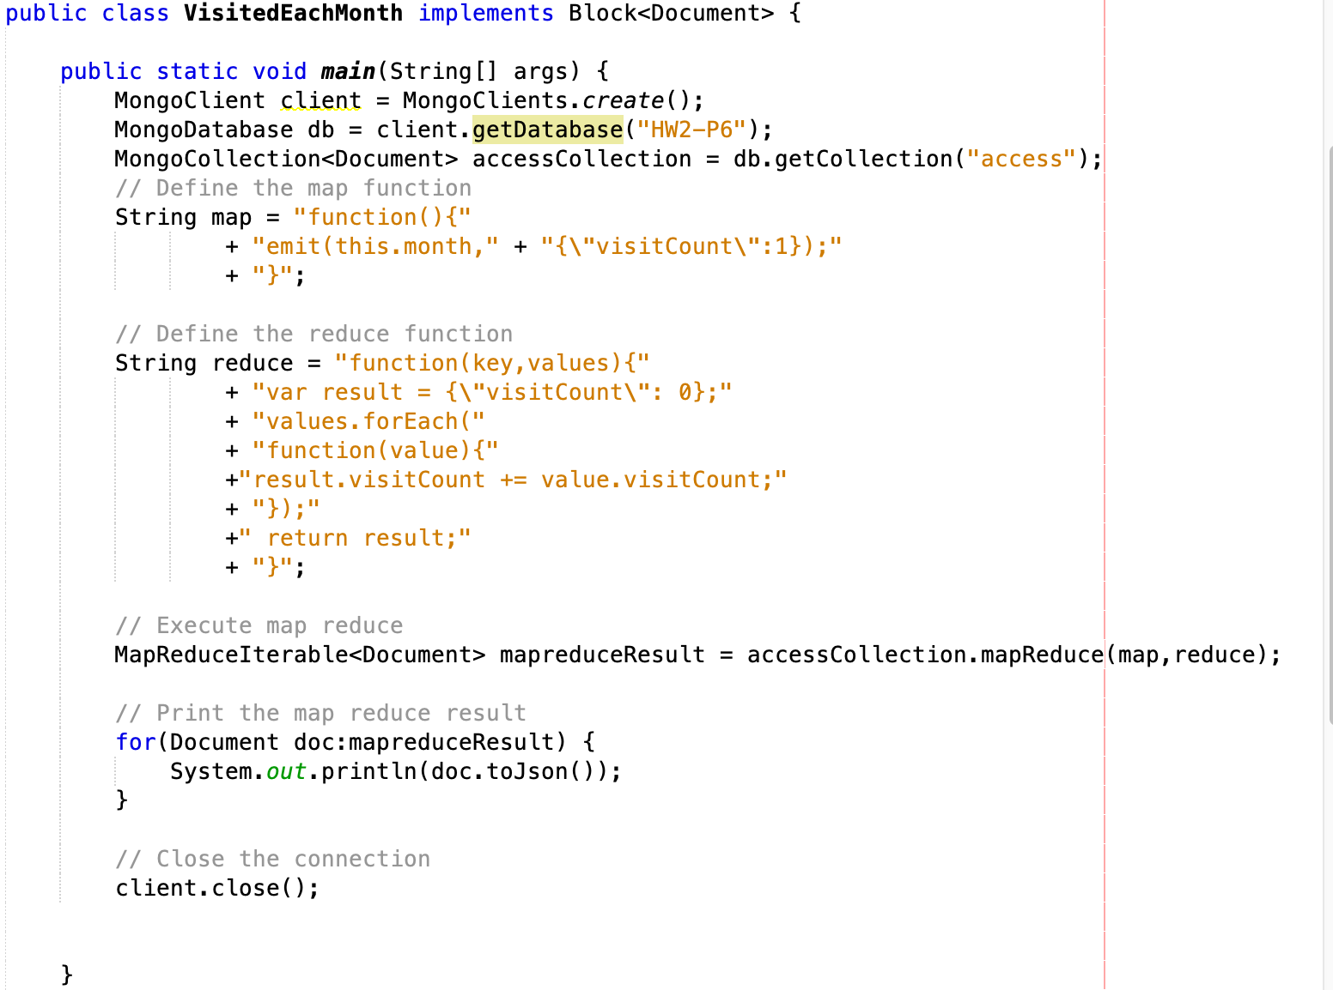

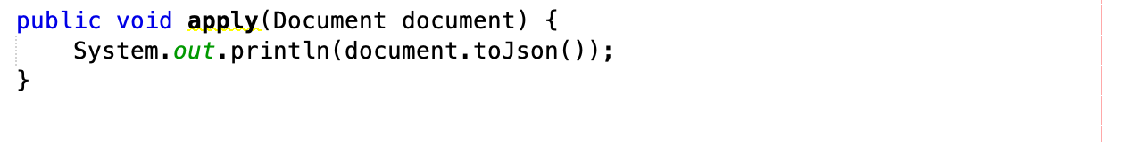

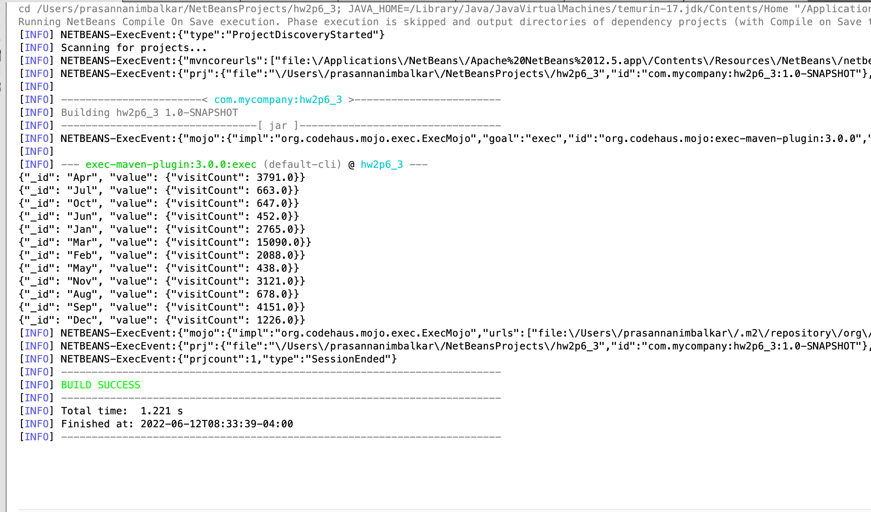

=====================================

PART 7 - PROGRAMMING ASSIGNMENT  
Redo Part-6 using Aggregation Pipeline.

Part7-1

- Number of times any webpage was visited by the same IP address.

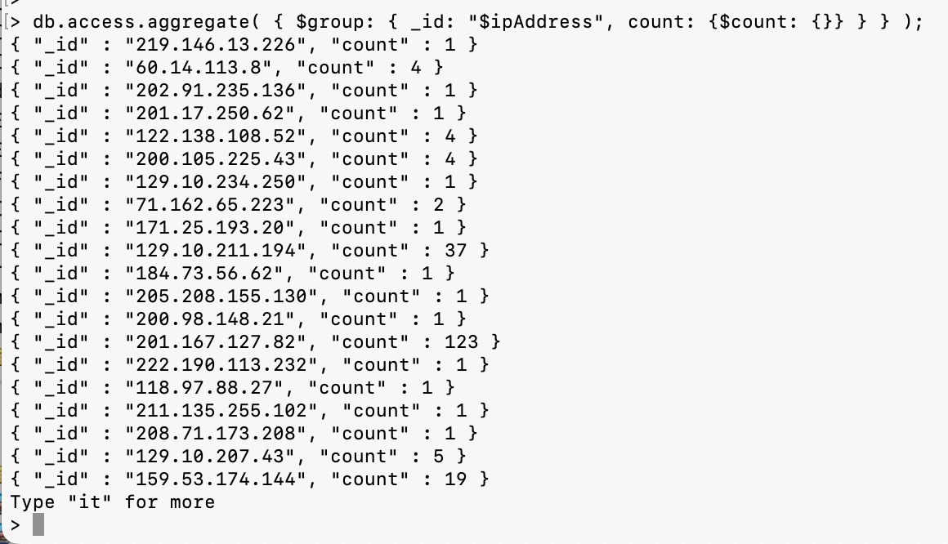

Part7 -2

- Number of times any webpage was visited each month.

